דף שער



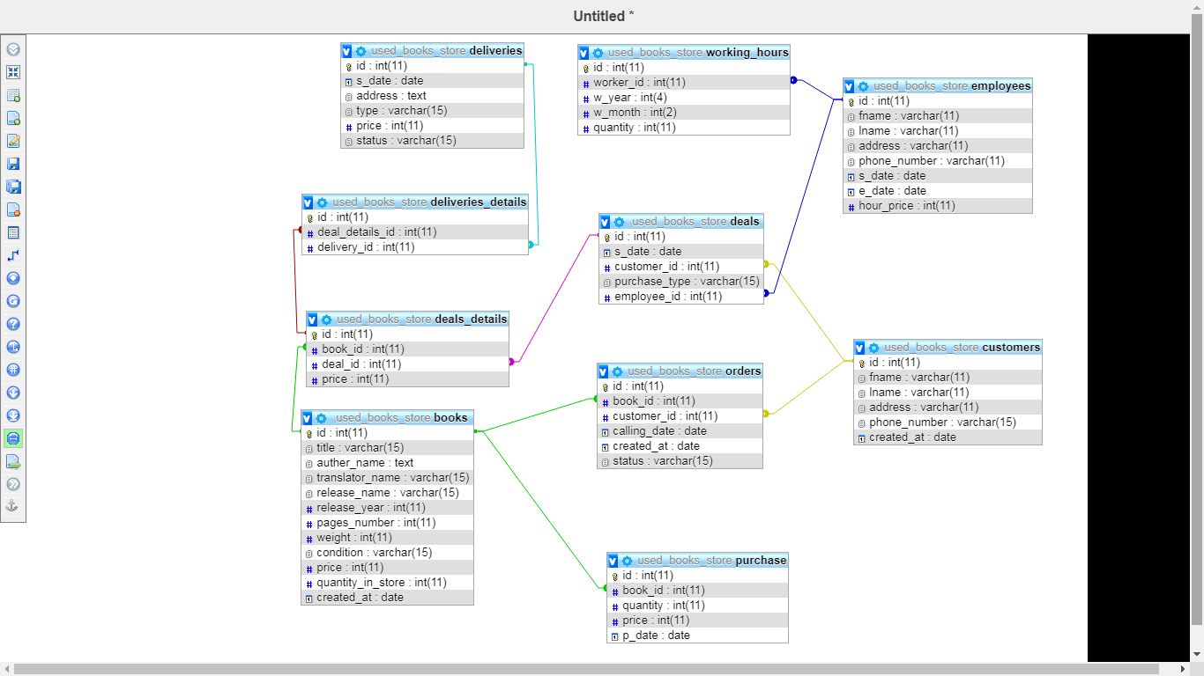

הנחות:

לכול ספר יש N רכישות, ולכול רכישה יש ספר אחד

לכול לקוח N הזמנות, ולכול הזמנה לקוח אחד וספר אחד

לכול לקוח N עסקאות, ולכול עסקה לקוח אחד

לכל עסקה יש N ספרים, ולכל ספר נמכר בM עסקאות

לכל ספר יש M משלוחים, ובכל משלוח N ספרים

לכל עובד יש N עסקאות ולכל עסקה עובד אחד

לכל עובד יש N שעות עבודה ולכל שעת עבודה עובד אחד

ספרים

|  |  |  |  |
| --- | --- | --- | --- |
| **Column** | **Type** | **Null** | **Default** |
| ***id*** | int(11) | No |  |
| title | varchar(15) | No |  |
| auther_name | text | No |  |
| translator_name | varchar(15) | No |  |
| release_name | varchar(15) | No |  |
| release_year | int(11) | No |  |
| pages_number | int(11) | No |  |
| weight | int(11) | No |  |
| condition | varchar(15) | No |  |
| price | int(11) | No |  |
| quantity_in_store | int(11) | No |  |
| created_at | date | No |  |

|  |  |  |  |  |  |  |  |  |  |  |  |
| --- | --- | --- | --- | --- | --- | --- | --- | --- | --- | --- | --- |
| 1 | book1 | auther3 |  | book1 | 2020 | 19 | 200 | new | 30 | 5 | 2020-07-06 |
| 2 | book1 | auther4,aurther5 |  | book2 | 2020 | 19 | 200 | old | 15 | 4 | 2020-07-05 |
| 3 | book2 | author1,author2 |  | book2 | 1995 | 50 | 350 | new | 45 | 0 | 2020-07-06 |
| 4 | book2 | author1,author2 | translator1 | book2 arabic | 1995 | 354 | 350 | good | 60 | 0 | 2020-07-03 |

לקוחות

|  |  |  |  |
| --- | --- | --- | --- |
| **Column** | **Type** | **Null** | **Default** |
| ***id*** | int(11) | No |  |
| fname | varchar(11) | No |  |
| lname | varchar(11) | No |  |
| address | varchar(11) | No |  |
| phone_number | varchar(15) | No |  |
| created_at | date | No |  |

|  |  |  |  |  |  |
| --- | --- | --- | --- | --- | --- |
| 123 | customer1 | customer1 | address1 | 123456789 | 2020-07-01 |
| 456 | customer2 | customer2 | address2 | 234567891 | 2020-07-02 |
| 789 | customer3 | customer3 | address3 | 345678912 | 2020-07-03 |

עסקאות

|  |  |  |  |
| --- | --- | --- | --- |
| **Column** | **Type** | **Null** | **Default** |
| ***id*** | int(11) | No |  |
| s_date | date | No |  |
| customer_id | int(11) | No |  |
| purchase_type | varchar(15) | No |  |
| employee_id | int(11) | No |  |

|  |  |  |  |  |
| --- | --- | --- | --- | --- |
| 1 | 2020-07-09 | 123 | credit card | 1111 |
| 2 | 2016-07-16 | 456 | bit | 2222 |
| 3 | 2020-06-21 | 789 | bank bass | 2222 |
| 4 | 2020-07-08 | 789 | Bit | 2222 |

פרטי עסקאות

|  |  |  |  |
| --- | --- | --- | --- |
| **Column** | **Type** | **Null** | **Default** |
| ***id*** | int(11) | No |  |
| book_id | int(11) | No |  |
| deal_id | int(11) | No |  |
| price | int(11) | No |  |

|  |  |  |  |
| --- | --- | --- | --- |
| 1 | 1 | 1 | 30 |
| 2 | 2 | 1 | 15 |
| 3 | 3 | 2 | 45 |
| 4 | 4 | 3 | 60 |
| 5 | 3 | 4 | 14 |
| 6 | 4 | 4 | 60 |

משלוחים

|  |  |  |  |
| --- | --- | --- | --- |
| **Column** | **Type** | **Null** | **Default** |
| ***id*** | int(11) | No |  |
| s_date | date | No |  |
| address | text | No |  |
| type | varchar(15) | No |  |
| price | int(11) | No |  |
| status | varchar(15) | No | binding |

|  |  |  |  |  |  |
| --- | --- | --- | --- | --- | --- |
| 1 | 2020-07-21 | address1 | post | 16 | binding |
| 2 | 2020-07-21 | address2 | xpress | 46 | binding |
| 3 | 2020-07-09 | address3 | post express | 49 | binding |
| 4 | 2020-07-07 |  | xpress | 30 | binding |

פרטי משלוחים

|  |  |  |  |
| --- | --- | --- | --- |
| **Column** | **Type** | **Null** | **Default** |
| ***id*** | int(11) | No |  |
| deal_details_id | int(11) | No |  |
| delivery_id | int(11) | No |  |

|  |  |  |
| --- | --- | --- |
| 1 | 1 | 1 |
| 2 | 2 | 2 |
| 3 | 3 | 3 |
| 4 | 5 | 4 |
| 5 | 6 | 4 |

עובדים

|  |  |  |  |
| --- | --- | --- | --- |
| **Column** | **Type** | **Null** | **Default** |
| ***id*** | int(11) | No |  |
| fname | varchar(11) | No |  |
| lname | varchar(11) | No |  |
| address | varchar(11) | No |  |
| phone_number | varchar(11) | No |  |
| s_date | date | No |  |
| e_date | date | Yes | NULL |
| hour_price | int(11) | No |  |

|  |  |  |  |  |  |  |  |
| --- | --- | --- | --- | --- | --- | --- | --- |
| 1111 | employee1 | employee1 | address1 | 1122334455 | 2020-07-08 | NULL | 29 |
| 2222 | employee2 | employee2 | address2 | 2233445566 | 2020-07-06 | NULL | 34 |
| 3333 | employee3 | employee3 | address3 | 3344556677 | 2020-07-03 | 2020-07-22 | 31 |

שעות עבודה

|  |  |  |  |
| --- | --- | --- | --- |
| **Column** | **Type** | **Null** | **Default** |
| ***id*** | int(11) | No |  |
| worker_id | int(11) | No |  |
| w_year | int(4) | No |  |
| w_month | int(2) | No |  |
| quantity | int(11) | No |  |

|  |  |  |  |  |
| --- | --- | --- | --- | --- |
| 1 | 1111 | 2020 | 6 | 135 |
| 2 | 1111 | 2020 | 7 | 122 |

הזמנות

|  |  |  |  |
| --- | --- | --- | --- |
| **Column** | **Type** | **Null** | **Default** |
| ***id*** | int(11) | No |  |
| book_id | int(11) | No |  |
| customer_id | int(11) | No |  |
| calling_date | date | Yes | NULL |
| created_at | date | No |  |
| status | varchar(15) | No | binding |

|  |  |  |  |  |  |
| --- | --- | --- | --- | --- | --- |
| 1 | 1 | 123 | NULL | 2020-07-25 | binding |
| 2 | 4 | 789 | 2020-07-04 | 2020-07-01 | binding |

רכישות חנות

|  |  |  |  |
| --- | --- | --- | --- |
| **Column** | **Type** | **Null** | **Default** |
| ***id*** | int(11) | No |  |
| book_id | int(11) | No |  |
| quantity | int(11) | No |  |
| price | int(11) | No |  |
| p_date | date | No |  |

|  |  |  |  |  |
| --- | --- | --- | --- | --- |
| 1 | 1 | 20 | 10 | 2020-07-01 |
| 2 | 2 | 15 | 9 | 2020-07-01 |
| 3 | 3 | 12 | 11 | 2020-06-01 |
| 4 | 4 | 16 | 8 | 2020-06-02 |

1. SELECT * FROM books WHERE title = 'auther' OR auther_name like '%auther%'
2. SELECT * FROM `customers` ORDER BY created_at LIMIT 1
3. SELECT * FROM `books` ORDER BY created_at LIMIT 1
4. SELECT * FROM orders WHERE status = 'binding' ORDER BY created_at
5. SELECT books.id, books.title, books.auther_name, books.translator_name, books.release_name, books.release_year, books.condition, COUNT(deals_details.id) AS 'counts'   
   FROM deals_details   
   JOIN books ON deals_details.book_id = books.id   
   WHERE books.title = 'auther' OR books.auther_name like '%auther%'   
   GROUP BY books.id, books.title, books.auther_name, books.translator_name, books.release_name, books.release_year, books.condition
6. SELECT books.auther_name,COUNT(books.id)   
   FROM deals_details JOIN books ON deals_details.book_id = books.id  
   JOIN deals ON deals_details.deal_id = deals.id   
   WHERE deals.s_date BETWEEN '2020-01-01' AND '2020-01-01'   
   GROUP BY books.auther_name ORDER BY COUNT(books.id)
7. SELECT customers.*, COUNT(deals_details.id) as 'reads'   
   FROM deals_details   
   JOIN deals ON deals_details.deal_id = deals.id  
    JOIN customers ON deals.customer_id = customers.id   
   GROUP BY customers.id, customers.fname, customers.lname, customers.address, customers.phone_number, customers.created_at   
   ORDER BY COUNT(deals_details.id) DESC   
   LIMIT 3
8. SELECT books_translated.title, COUNT(books_translated.title)   
   FROM(  
    SELECT books.title, books.translator_name  
    FROM books  
    GROUP BY books.title, books.translator_name) AS books_translated   
   GROUP BY books_translated.title   
   ORDER BY COUNT(books_translated.title) DESC   
   LIMIT 1
9. SELECT books.*, deals.s_date   
   FROM deals_details   
   JOIN deals ON deals_details.deal_id = deals.id   
   JOIN books ON deals_details.book_id = books.id   
   WHERE cast(deals.customer_id AS CHAR) = '123'   
   ORDER BY deals.s_date
10. SELECT books.id,books.title,books.translator_name, orders.created_at,   
    IF(books.id IN(SELECT purchase.book_id FROM purchase), 'yes', 'no') AS 'in_inventory', IF(books.id IN(SELECT deals_details.book_id   
     FROM deals_details   
     JOIN deals ON deals_details.deal_id = deals.id   
     WHERE deals.customer_id = 123), 'yes', 'no') AS 'deal'   
    FROM books   
    JOIN orders ON orders.book_id = books.id   
    WHERE orders.customer_id = 123
11. ש
12. SELECT customers.id, CONCAT(customers.fname,' ',customers.lname) AS name,deliveries.*   
    FROM customers   
    JOIN deals ON deals.customer_id = customers.id   
    JOIN deals_details ON deals_details.deal_id = deals.id  
    JOIN deliveries_details ON deliveries_details.deal_details_id = deals_details.id   
    JOIN deliveries ON deliveries_details.delivery_id = deliveries.id   
    WHERE deals.id IN(  
     SELECT deals.id  
     FROM customers   
     JOIN deals ON deals.customer_id = customers.id   
     JOIN deals_details ON deals_details.deal_id = deals.id   
     JOIN deliveries_details ON deliveries_details.deal_details_id = deals_details.id  
     GROUP BY customers.id, CONCAT(customers.fname, ' ', customers.lname), deals.id   
     HAVING COUNT(deliveries_details.id) >= 2)
13. SELECT deliveries.*   
    FROM deals   
    JOIN deals_details ON deals_details.deal_id = deals.id   
    JOIN deliveries_details ON deliveries_details.deal_details_id = deals_details.id  
    JOIN deliveries ON deliveries_details.delivery_id = deliveries.id   
    WHERE deals.customer_id = 123
14. SELECT COALESCE(SUM(deliveries.price),0)   
    FROM deliveries WHERE deliveries.type = 'xpress'   
    AND MONTH(deliveries.s_date) = 8
15. SELECT COALESCE(SUM(deals_details.price),0)   
    FROM deals JOIN deals_details ON deals_details.deal_id = deals.id   
    WHERE deals.purchase_type = 'Bit'   
    AND MONTH(deals.s_date) = 77
16. SELECT deals.id, SUM(deals_details.price) as avrage   
    FROM deals JOIN deals_details ON deals_details.deal_id = deals.id   
    WHERE deals.s_date >= DATE_SUB(NOW(), INTERVAL 1 YEAR)   
    GROUP BY deals.id   
    HAVING average > (  
     SELECT AVG(sum_deals.avrage)  
     FROM(  
     SELECT deals.id, SUM(deals_details.price) as average  
     FROM deals JOIN deals_details ON deals_details.deal_id = deals.id  
     WHERE deals.s_date >= DATE_SUB(NOW(), INTERVAL 1 YEAR)

GROUP BY deals.id) AS sum_deals)

1. SELECT deliveries.type, COUNT(deliveries.id)   
   FROM deliveries   
   WHERE deliveries.s_date >= DATE_SUB(NOW(), INTERVAL 1 YEAR)   
   AND(deliveries.type = 'xpress' OR deliveries.type = 'post')   
   GROUP BY deliveries.type
2. SELECT deliveries_details.delivery_id, books.title, COUNT(books.id) AS releases_number FROM deliveries_details  
   JOIN deals_details ON deals_details.id = deliveries_details.delivery_id   
   JOIN books ON books.id = deals_details.book_id   
   GROUP BY deliveries_details.delivery_id, books.title, books.release_name   
   HAVING COUNT(books.id) >= 2
3. SELECT DISTINCT customers.*   
   FROM customers   
   JOIN deals ON deals.customer_id = customers.id   
   WHERE customers.id AND deals.s_date < DATE_SUB(NOW(), INTERVAL 2 YEAR)
4. SELECT DISTINCT customers.*   
   FROM customers   
   JOIN orders ON orders.customer_id = customers.id   
   WHERE orders.calling_date < DATE_SUB(NOW(), INTERVAL 2 WEEK)
5. SELECT DISTINCT YEAR(purchase.p_date) AS a_year, MONTH(purchase.p_date) AS a_month, (   
    SELECT SUM(purchase.quantity)   
    FROM purchase   
    WHERE YEAR(purchase.p_date) <= a_year   
    AND MONTH(purchase.p_date) <= a_month) -  
    (SELECT COUNT(deals_details.id)   
    FROM deals_details JOIN deals ON deals_details.deal_id = deals.id  
    WHERE YEAR(deals.s_date) <= a_year   
    AND MONTH(deals.s_date) <= a_month) AS books_count   
   FROM purchase
6. SELECT SUM(purchase.quantity), SUM(purchase.quantity*purchase.price)   
   FROM purchase   
   WHERE purchase.p_date BETWEEN '1-1-2020' AND '30-9-2020'
7. SELECT COALESCE(  
    (SELECT SUM(purchase.price * purchase.quantity)   
    FROM purchase   
    WHERE MONTH(purchase.p_date) = 7   
    AND YEAR(purchase.p_date) = 2020) –   
    (SELECT SUM(deals_details.price)   
    FROM deals_details  
    JOIN deals ON deals.id = deals_details.deal_id  
    WHERE MONTH(deals.s_date) = 7  
    AND YEAR(deals.s_date) = 2020),0) AS store_pro
8. SELECT monthly_sum.a_year, AVG(monthly_sum.a_sum)   
   FROM (  
    SELECT MONTH(deals.s_date) AS a_month, YEAR(deals.s_date) AS a_year,  
    SUM(deals_details.price) AS a_sum  
    FROM deals  
    JOIN deals_details ON deals.id = deals_details.deal_id  
    GROUP BY MONTH(deals.s_date), YEAR(deals.s_date)) AS monthly_sum  
    GROUP BY monthly_sum.a_year
9. SELECT COALESCE(SUM(working_hours.quantity * employees.hour_price),0) AS salary FROM employees JOIN working_hours ON working_hours.worker_id = employees.id WHERE working_hours.w_month = 7   
   AND working_hours.w_year = 2020 AND employees.id = '123'
10. SELECT employees.id, employees.fname, employees.lname   
    FROM employees JOIN deals ON deals.employee_id = employees.id   
    WHERE MONTH(deals.s_date) = 8 AND YEAR(dealss_date) = 8   
    ORDER BY COUNT(deals.id) DESC   
    LIMIT 1